CAPABILITIES DOCUMENT

Project: ECSE 211 Search & Retrieval Robot
Task: Overall design

Document Version Number: 1.4
Date: February 18, 2020
Author: Yanis Jallouli
Edit History:
Date | Version | Author(s) | Changes
Feb 18 | 1.0 | Yanis Jallouli | Initial Draft
Feb 18 | 1.1 | William Bouchard | Formatting of the document  Updated Section 3.0 for everyone
Feb 21 | 1.2 | Andy Li | Updated formatting of Section 2
Mar 30 | 1.3 | Andy Li | Updated critical event dates
Apr 13 | 1.4 | Andy Li | Added update on remote work

1.0 TABLE OF CONTENTS
2.0 – TEAM MEMBERS 3
3.0 – CAPABILITIES 4
4.0 – POSSIBLE APPLICATION AREAS 5
5.0 – AVAILABILITY 6
6.0 – REMOTE WORK UPDATE 7
7.0 – GLOSSARY OF TERMS 7

2.0 – TEAM MEMBERS

Name | Email | Phone
William Bouchard | william.bouchard3@mail.mcgill.ca | 418-573-0193
Yanis Jallouli | yanis.jallouli@mail.mcgill.ca | 727-542-0435
Andy Li | andy.s.li@mail.mcgill.ca | 438-938-8088
Trevor Tabah | trevor.tabah@mail.mcgill.ca | 514-887-4081
Benjamin Weiss | benjamin.weiss3@mail.mcgill.ca | 647-876-6100
Seyed Yazdan Zinati | seyed.zinati@mail.mcgill.ca | 438-600-1913

3.0 – CAPABILITIES
Name | Software  Experience | Hardware  Experience | Testing  Experience | Organization | Leadership
William Bouchard | Proficient in Java, C, Python, Dart  Experience with Git and Github  Experience with Object Oriented Programming | Very basic circuit analysis (ECSE 200)  Experience with Lego | JUnit tests  Frontend tests (Vue) | Created a soccer team from scratch and organized it for 2 years | Leadership role in sports team.
Yanis Jallouli | Proficient in Java and C++ development.  Minor experience with Git and GitHub | Basic circuit analysis (ECSE 210) | Designed Unit and integration tests  (ECSE 321) | No experience | Leadership role in sports team.  No formal team management experience
Andy Li | Some experience in Java and C++ | Experience with Lego Mindstorms  Circuit and signal analysis (ECSE 200, 206, 210, 222) | No formal testing experience | Executive organizational role in major club (2 years) | Limited experience in leadership
Trevor Tabah | Proficient in Java and Python Development | No experience | JUnit tests (ECSE321) | No experience | Leadership roles in numerous sports teams
Ben Weiss | Proficient in Java building, developing & debugging.  Experience with Agile Development (ECSE 321) | No experience | Created JUnit tests  (ECSE 321) | No experience | Managed groups of 5-6 in business case competitions
Seyed Yazdan Zinati | Proficient in Java and concept of OOP  Experienced in Python, C and C++ | Circuit analysis  Signals and systems  Controls | No formal testing experience | Managed a small team in a programming competition for 2018 RoboCup | Leadership roles in group projects and sports

4.0 – POSSIBLE APPLICATION AREAS
NAME | Software | Hardware | Testing | Organization | Leadership
William Bouchard | X | O | O | O
Yanis  Jallouli | O |  | X |  | O
Andy  Li | O | O |  | X
Trevor  Tabah | O |  | O |  | O
Ben  Weiss | O |  | O |  | X
Yazdan  Zinati |  | X |  | O

O = Capability (self-assessed)
X = Primary assigned role

5.0 – AVAILABILITY
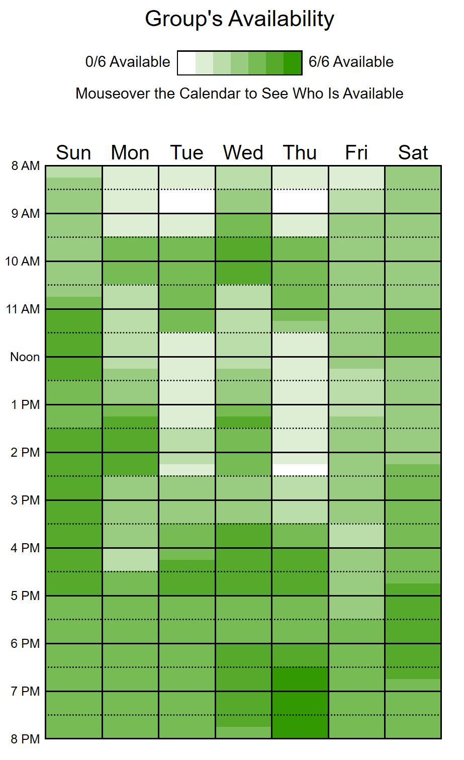
For a breakdown of availability by member, see https://www.when2meet.com/?8773591-7ut4c
Critical events
February 25 - Lab 5 Demo
March 02 - March 06 - Study break
March 30 - Final design meeting
April 08 - April 09 - Final management presentation
April 14 - Documentation due date

6.0 – REMOTE WORK UPDATE
Due to the suspension of classes between March 13 and March 27 and the change to online communication since then, we are no longer able to meet in person. However, we can continue to communicate using tools such as Zoom and Google Drive. All members of the team have access to a computer with a webcam and an internet connection. In addition, the members are all currently located in the Eastern time zone.

7.0 – GLOSSARY OF TERMS
- Lego Mindstorms – A kit made by Lego containing parts used to build small robots, which can be programmed using LeJOS EV3 software
- ECSE – Designation for a McGill course in electrical, software, or computer engineering
- Business case competition – A competition in which teams with 5-6 members present and defend a solution to a given problem

